PROJECT DOCUMENTATION

Title: OCR-Based Document Extraction

Objective:
To develop an intelligent system that extracts key information from scanned Aadhaar cards,Pan Cards and Driving License using Optical Character Recognition (OCR) and automates the filling of digital loan application forms. The solution must retrieve all necessary fields including the photo, name, date of birth, gender, card numbers, mobile number, and full address from the uploaded document images.

Technologies Used:
1. Python
2. OpenCv - for Image Preproessing
3. Pytesseract - Ocr Engine for text recognitiom.
4. Re – Regular Expressions for text parsing.
5. Streamlit - Frontend

Working:
1. Image Input:
- Document images are uploaded through the Streamlit web interface.
- Accepts formats like JPG, JPEG, PNG.
2. Image Preprocessing:
- The uploaded image is converted to grayscale.
- Thresholding is applied to enhance text clarity.
- Noise is reduced to improve OCR accuracy.
3. Text Extraction with OCR:
- pytesseract is used to extract the full textual content from the preprocessed image.
- Extracted text is cleaned and parsed line-by-line.

4. Field Extraction using Regex:
The following fields are detected for respective documents:
- Name
- Date of Birth
- Gender
- Address
- Aadhaar Number
- Pan Identification Number
- Driving License Number
- Validity for License
Regex patterns are applied to extract and validate each field from the text block.
5. Face Photo Extraction:
- The image is scanned using Haar Cascade classifiers to detect and crop the face image.
- The extracted photo is displayed alongside text fields.
6. Display Results:
- The UI displays all fields in a clean, center-aligned layout.
- User gets a preview of:
Aadhar Card
  - Detected Name, DOB, Gender, Address, Aadhar number,Extracted Photo
Pan Card
  - Detected Name, Pan Identification Number,Father Name, DOB, Photo
Driving License
  - Detected Name, Driving License Number,Address,Validity, DOB, Extracted Photo.

Sample Output:


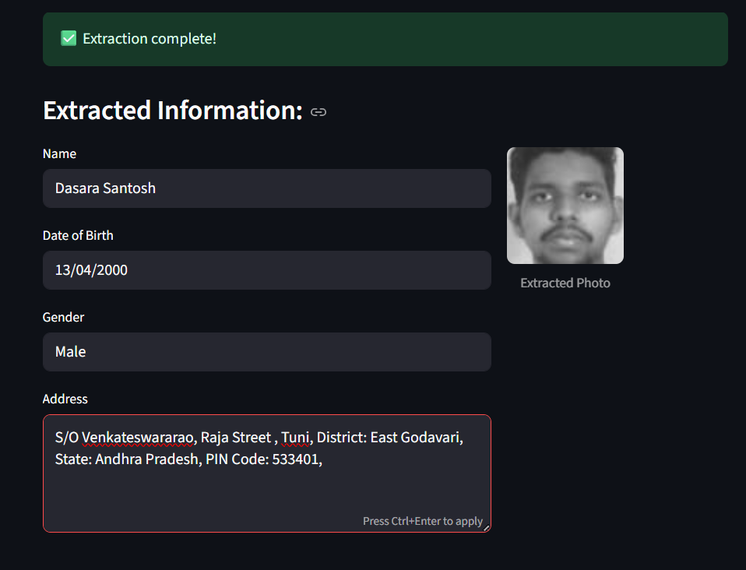
Conclusion:
This project effectively demonstrates how OCR and computer vision can automate the data extraction process from government-issued identity cards. It minimizes human error, increases operational efficiency, and offers a scalable solution for digitization of identity data.

